**Full Event Particle-Level Unfolding with Variable-Length Latent Variational Diffusion Paper Review**

Paper Review by Tyler Kim

**Motivation**

* Reweighting approach works well for high dimensional approach but struggles with fewer observed events
* Generative model approach does not suffer from fewer observed events because it relies on simulations yet handling variable dimensions can be difficult
* Unfolding methods optimized on simulation relies heavily on prior distribution used to construct training data

**Proposal/Contributions**

* Variational latent diffusion (VLD) model extended from Irvine paper to variable dimensional set of observables enabling full-event unfolding event even with fewer observed events
* Assess prior dependence of VLD model

* Learn distribution of one set of objects conditioned on another set of objects
* : particle level observations, : detector level observations
* Uses loss function from Irvine paper
* Process
  + During inference time, detector level event is mapped to latent embedding and produces a multiplicity prediction
  + Multiplicity prediction and latent embedding used for condition diffusion process which yields sample from latent space of particle VAE
  + Particle decoder produces sample from learning conditional distribution
* **Particle VAE**: Learn efficient mapping for low-level observables of particle-level events into a latent space optimized for the diffusion process
  + Unlike Irvine paper, latent space of the VAE is coupled directly to diffusion process
* **Detector Encoder**: encode detector observations into conditional latent space Y and outputs dimensional vectors
* **Multiplicity Predictor**: accommodate the generation of variable-length particle-level events
  + Transformer processes latent to extract multiplicity features
  + Deep MLP estimates parameters such as shape and scale of gamma distribution which can then be sampled from while unfolding an event
* **Latent Diffusion Process**: learns the conditional distribution
* **Particle Denoising Network**: uses encoder-only transformer architecture to predict the noise

* **Noise Schedule Network**: determines the magnitude of noise throughout time
* **Inferencing** **Steps**
  + Encode detector observable
  + Extract multiplicity latent vector
  + Sample multiplicity
  + Sample for prior distribution
  + Perform reverse diffusion using ODE solver
  + Predict final particle-level observables via decoding

**Key Findings**

* **Semi-leptonic Unfolding**
  + Dataset
    - MADGRAPH for matrix element calculation
      * Used Standard model
    - PYTHIA8 for parton showering and hadronization
    - DELPHES for simulation of experimental apparatus
  + Excellent agreement between unfolded and truth distributions for inclusive lepton and jet kinematics
  + Disagreements found at kinematic edges
  + Figures below show how well the unfolding worked for various distributions

* Generally, unfolded distribution was closer to truth distribution than detector distribution
* Excellent agreement between jet multiplicity distribution
  + They tested the jet multiplicity robustness and found that the truth-level kinematic distributions is independent of the jet multiplicity

* + They also used pseudo-top algorithm from [69,70] to reconstruct hadronically- and leptonically decaying top quark candidates => check performance of unfolding kinematics on these reconstructed system
    - Demonstrate that their proposal can obtain unfolded distribution of an arbitrary new observable
    - Struggled with top quark mass distributions

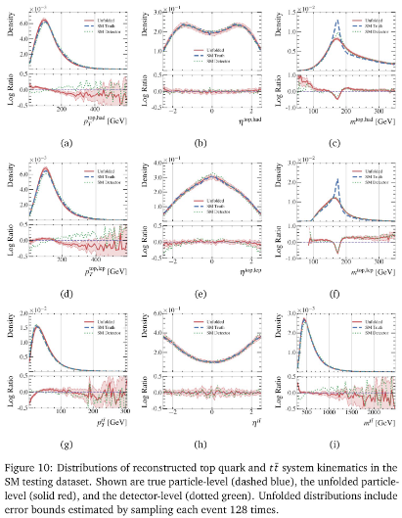

* + The table above shows the distances between the true distribution and each of the kinematic observable distributions from the model for hadronically decaying, leptonically decaying, and system
  + In some cases, unfolded is slightly further from truth distribution than that of the detector-level distribution
  + The researchers further probed the model by adding more event-level observables which yielded remarkably good agreement between truth and unfolded
* **Performance on Dataset with BSM Physics Injection**
  + Evaluated VLD network on alternative sampling containing BSM physics parametrized with non-zero EFT operator
  + Found that choice of prior training sample does not induce significant bias in unfolding derived using VLD

